Seeing Is No Longer Believing: Teaching Visual Literacy in the Age of AI
With the invention of the technology such as cameras, the phrase “Seeing is believing” used to have some validity to it. But in today’s age, can we trust that images or videos we see are things we should believe? With the increasing use of artificial intelligence (AI) and language learning models (LLMs), exposure to artificially generated images or content becomes a regular occurrence. In 2017, we saw the introduction of the transformer architecture of language learning models (Vaswani et al., 2017) which became the backbone of models such as ChatGPT. Companies are now using AI generated images to advertise their products, social media companies are incorporating AI into many of their apps, and schools are having to combat a new form of plagiarism as students attempt to pass off AI-written work as their own. As AI becomes increasingly present and more advanced, while being cheap for the consumer, it is important to be skeptical when evaluating sources of content for AI generated material to avoid falling prey to misinformation, scams, or other exploitative content. This research looks at common artifacts in AI generated images to train participants to spot some of the key giveaways that an image is AI generated or altered.
Fake news is described as the production, consumption, and distribution of false information through digital channels, often disguised as credible content (Giordano et al., 2025). While the origin of false or misleading stories predates our historical records, we as humans could not instantly relay images or video to mass audiences until the invention of the television. When the internet started to make its way into American homes, it gave anyone with internet access the ability to quickly disseminate and consume news. Now that we have access to LLMs and AI programs, disseminating news and information to large audiences becomes automatic. These generative systems can create entirely fabricated stories, images, and even videos without building in a way for people to easily discern what’s real and what’s not. Otgaar et al. (2022) describes false memories as recollections of events that never occurred or are distorted versions of actual events, often formed through suggestive influences or misinformation. The two main processes that factor into false memories are belief and recollection, though they are not mutually exclusive. False memories stemming from fake news are suggestion-induced, as they are being provided to influence the audience to believe what they are claiming. It is important to also factor repetition into the increase in belief of false memories, as research shows that the more frequently someone has been shown a false story, the more likely they are to believe it is true (Grinfeld, 2025).
Image generating artificial intelligence models include models such as generative adversarial networks (GAN), variational autoencoders (VAEs), or diffusion models. A literature review conducted by Chen et al. (2024) describes VAEs as generative models that are trained on images by reducing them down to unique characteristics and then building a new image based off the combination of these unique image characteristics. GANs are described as image generators that compete between the image that it is generating and the model’s perceived realness of the image being generated. The article detailed by Chen et al. (2024) describes diffusional models as having surpassed the ability of GANs or VAEs, as diffusion models begin with an image that is entirely comprised of the “noise” of the various images it has been trained on, and with each step, it reduces the noise to produce a clear image. Both the article by Chen et al. (2024) as well as an experiment conducted by Ho et al. (2020) detail that all types of image-generating artificial intelligence models are incapable of replicating images exactly, as they create images based off of the amalgamation of the thousands or millions of images that the model is trained on. Even when provided a copy of an image to be replicated with text prompts to copy the image, the image generation models begin with alternative materials and edit the image until it shares similarities or features with the original image.
When discussing the use of AI, especially under the context of the ease of access to image and video generation to the general public, it is important to consider the ethical implications of the use of language learning models or image-generating models and the potential data they’re trained on. Illia et al. (2022) described many of the ethical challenges with generative AI, such as its ability to amplify biases and learn implicit patterns from data related to sexism, racism, gender inequalities, and other discriminations towards minorities. The research further detailed the lack of information regarding the data particular models are trained with, and a lack of responsibility for the type of information that the AI generates. Zhou et al. (2024) collected online comments surrounding Sora, OpenAI’s advanced text-to-video generative AI model, many of which showed public concern for Sora’s ability to create content that blurs the lines between real and fake content. Both the studies by Illia et al. (2022) and Zhou et al. (2024) discuss the ethical considerations of data privacy and copyright issues as additional aspects of the ethical challenges of generative AI and the data they are trained with.
Research conducted by Pataranutaporn et al. (2025) utilized AI to edit or generate fake images and used a control group that showed legitimate images that were not created or edited by AI. When evaluating their memory of the images, they also measured their level of confidence in the accuracy of their memory. The research showed that AI-edited content not only boosts the likelihood of false memories, it showed that participants had a high degree of confidence in the accuracy of their recollection of false stories. Motoki et al. (2025) conducted multiple experiments to assess political bias of ChatGPT-3.5, ChatGPT-4, and DALL-E 3. When impersonating the political values of the “average American”, both ChatGPT-3.5 and ChatGPT-4 leaned further left than the known population distribution. For DALL-E 3 image generation, ChatGPT and Gemini were asked to analyze and compare generated images and then create prompts that were fed into DALL-E 3, which also showed more left-leaning results. The researchers noted that ChatGPT refused to generate images for certain themes such as racial equality, but only for the right-wing perspective, stating that it was refusing because creating an image from that perspective could “propagate stereotypes, misinformation, or bias”. The authors indicated that users must exercise caution when using any version of GPT with politically charged content as users are unlikely to receive entirely unbiased responses.
An important aspect to consider is the perceived vividness of the content being generated. Lee and Shin (2021) conducted two experiments, the first to evaluate the vividness of the content, and the results showed that the perceived vividness of the source was the highest with the deepfake video news condition versus an AI generated fake story that had only images and text. By conducting a second experiment that included tags to indicate to participants whether the news was fake, they found that including the tags was an effective way to weaken the strength of the validity which led to less engagement with the fake stories.
Guo et al. (2025) conducted an experiment aimed at providing specific media literacy tips regarding how to stop AI generated images with the goal to reduce the susceptibility to AI-generated visual misinformation (AVIM). They randomly assigned participants to one of three groups: a control group that were provided with no media literacy tips, a treatment group that provided general tips on spotting misinformation, and a second treatment group that provided specific media literacy tips aimed at detecting AVIM. Their research showed that both media literacy treatments reduced belief in AVIM compared to the control, with specific tips reducing belief in AVIM more than the general tips. They contrasted these positive results with results that also showed that the inclusion of both specific and general media literacy tips reduced belief in real headlines compared to the control.
The current study seeks to build on previously mentioned research by evaluating participant’s ability to discern between real, unedited photographs and AI-generated or AI-altered images. To avoid many of the ethical challenges described, the unedited photographs are provided by the principal investigator. Participants completed a survey consisting of a mix of 15 real, unedited photographs, AI-altered images, or fully AI-generated images to obtain a baseline score. Afterwards, they completed a treatment involving training participants to spot some of the key differences between real, unedited photographs and AI-altered images. After completion of the training portion, the participants completed a second survey with another set of 15 images to evaluate changes in scores. The study used a repeated-measures design, with the training module acting as the independent variable, and the two surveys as the dependent variables. A control group was not used for this study. We hypothesized that there will be a statistically significant difference between the baseline survey scores and the post-treatment scores of participants.
Method
Participants
Participants were recruited through the psychology department and university professors. The sample consisted of 90 individuals over the age of 18 with access to SONA. Three participant responses were excluded due to lack of responses to the surveys, yielding a total of 87 participants (76 females, 6 males, and 5 non-binary individuals). Participants’ ages were measured in predefined ranges, with the most common age range being 18-21 at 75.9%, followed by age 22-25 at 10.3%, and ranges 30-33 and 38-41 at 3.4%. The study was made available to be completed online in approximately 30 minutes, and participants were compensated with 2 SONA research credits. Once opening the link to the study, participants were first directed to the informed consent, which they had to read and sign before beginning the baseline survey. Contact information was provided in the informed consent for any questions they may have before proceeding. After agreeing to the informed consent, the online survey would assign them a random five-digit number to maintain confidentiality when recording answers.
Materials
A total of 45 unedited, unfiltered images were selected from the principal investigator’s iPhone camera roll. Copies were made of the original photographs, and then all 45 of the images were fed into OpenArt’s diffusion-based Juggernaut XL model. In order to closely replicate the reference photographs with key AI artifacts despite the model’s inability to create exact replicas of images, a text prompt stating, “Create an exact replica of this image, don’t change a thing” was included. The reference image was included in the “Image to image” guidance, with the creativity level set to an interval between 0.1-0.3 (range: 0.1-1.0, the higher this number is, the more creative AI is and less similar the output image is to the original image). Prompt adherence was set to 15 (range: 1-15, indicates how strictly the model will stick to the prompt. Lower numbers let AI be more creative, while higher numbers force it to stick to the text prompt.) All images were set to 25 steps (how many steps the AI runs through before generating the final image) and upscaled to the highest resolution. An additional 8 images from the original set of 45 were generated into text prompts via OpenArt’s “Image to Prompt” feature creating a detailed prompt using GPT-4o-mini. The generated prompt was input into the text prompt box with the previous prompt to replicate the image removed, and the “Image to image” guidance box was intentionally left blank. All other settings remained the same.
The survey was conducted online using Qualtrics with the same question and answers for each survey question but a different image for each question. Each question began with: “Identify the following image as either a real, unedited photograph taken by a person OR an AI-generated/AI-altered image. You will have a maximum time limit of 60 seconds to view the image.” JavaScript and HTML coding were utilized to give participants a maximum time limit of 60 seconds to analyze each image. A countdown timer displayed above the image to inform participants of the time remaining. After 60 seconds, the image disappeared, but the survey question and answers remained. They were then prompted to pick between two answer options: “Real photograph” or “AI-generated/AI-altered”. Each survey was scored out of 15 to provide pre- and post-training scores. Figure 5 shows an example of one of the survey questions with an AI-generated image that participants may have been randomly assigned during the first survey.
The treatment portion of the study included a training module consisting of a “Spot the Differences” game to make the content more engaging, and included 12 sets of images: an original, unaltered photograph and an AI-reprocessed image. The training was designed within Qualtrics to show one set of images on the screen simultaneously with clear labels, the real photograph appearing first, and the AI-reprocessed image below it, stating: “Click on one difference in the image below before continuing.” (See Figures 6 and 7). For the AI-reprocessed image, the Qualtrics “Hot spot” question type was utilized to allow key AI artifacts selected by the researcher to be highlighted in green when interacted with by the participants.
Procedure
Of the original 45 images that were run through OpenArt to create artificially reprocessed images, 12 sets of images (original and reprocessed versions) were turned into a training module to be completed after baseline Survey 1. To ensure participants were exposed to only one image from each set (original, reprocessed, or prompt generated), each image was assigned to a number. To balance the likelihood of a real photograph or AI-reprocessed/generated image being selected, images 1-8 were given 4 entries for the real image being included in the survey, 2 entries for the AI-reprocessed images, and 2 entries for the AI-generated images, which were shuffled and randomly selected. For images 9-45, 4 entries for the real image and 4 entries for the AI-reprocessed image were shuffled and randomly selected. Survey 1 included some of the training images and was comprised of a total of 24 images consisting of 8 real photographs, 15 AI-reprocessed images, and 1 AI-prompt generated image. A Qualtrics survey was programmed to randomly select 15 of the 24 total questions for each participant. Survey 2 included a total of 19 images consisting of 8 real photographs, 8 AI-reprocessed images, and 3 AI-prompt generated images, 15 of which were randomly selected for the second survey. Images included in Survey 1 were not included in Survey 2 and vice versa.
After completing Survey 1, participants then completed the training portion of the study that began with an introduction to the training module as well as a list of common AI mistakes including background elements, objects, and texture/lighting. The tips were adapted from the Reddit forum “r/RealOrAI” page titled Common AI Mistakes to Watch For (2025). Following the general tips, participants continued to the interactive “Spot the Differences” game portion of the training as described in Materials, observing 12 pairs of images, a real photograph and an AI-reprocessed version of the same photograph and selecting the differences in the AI-reprocessed image. After interacting with the AI-reprocessed image and navigating to the next page, they were shown a side-by-side comparison of the two images with differences magnified and provided a text section with “Key indicators” describing the AI-artifacts (Figure 8). After navigating through the training module, participants were prompted to complete Survey 2 with a second set of 15 images to determine if each image was real or AI-generated or altered.
Deception was not used for this study. At the end of the second survey, participants were debriefed and given information on the purpose of the study. After reading the debriefing section, participants were redirected back to SONA and credited with 2 research credits.
Results
Participants’ survey scores significantly increased following the training portion of the study. A paired-samples t-test showed that post-treatment survey scores (M = 11.66, SD = 2.25) were significantly higher than pre-treatment scores (M = 9.05, SD = 2.61), t(86) = -10.19, p < .001, 95% CI [-3.12, -2.10]. The training produced a substantial improvement in scores, demonstrating a large effect size with Cohen’s d = 1.09. A one-sample t-test of the difference between pre-treatment scores and post-treatment scores revealed that the mean difference in the number of correct answers between the pre- and post-training surveys was significant, t(86) = 10.17, p < .001, 95% CI [2.10, 3.12]. The average improvement after the training was 2.61 correct answers (SD = 2.39). A repeated measures ANOVA further confirmed a significant effect of the training on the post-treatment scores, F(1,86) = 103.38, p <.001, partial η² = .546, indicating that over half of the variance in scores was explained by the training portion of the study (See Table 3 and 4). Figures 2 and 3 provide visual representations of these results.
A repeated measures ANOVA was conducted to examine changes in survey scores with age, gender, and ethnicity included as between-subjects factors. Results revealed a significant improvement from the training, F(1, 64) = 24.36, p < .001, partial η² = .276. The between-subjects effects of age (p = .142), ethnicity (p = .074), and gender (p = .993) were not significant, suggesting that improvement was consistent across demographic groups. Table 1 displays the demographic frequencies of the individuals that participated in this study.
To evaluate the mean accuracy by image type, a 2x3 repeated measures ANOVA showed significant effects between surveys, F(1, 56) = 46.403, p < .001, partial η² = .453, and image type, F(2, 55) = 8.305, p < .001, partial η² = .232, indicating that accuracy varied across image types and that accuracy improved overall. The interaction between image types and surveys was also significant, F(2, 55) = 32.822, p < .001, partial η² = .544. The mean accuracies for the sums of the three image types across all questions can be seen in Table 2. Accuracy for AI-generated and AI-altered images increased from Survey 1 to Survey 2 while accuracy for real images slightly decreased, as displayed in Figure 1.
To ensure the appropriate use of parametric analyses of the data, visual analysis of histograms with normal curves and Q-Q plots showed that the data were approximately normally distributed with mild deviations. To further support the use of parametric analyses, a multiple regression analysis was conducted to predict improvement scores from pre-treatment survey score and demographic variables (See Figure 4). The overall model was significant, F(4, 80) = 12.495, p < .001, accounting for approximately 39% of variance in improvement scores (R² = .385). Only pre-treatment survey score was a significant predictor (p < .001), while age (p = .286), gender (p = .269), and ethnicity (p = .240) were not significant.
Discussion
The current study examined participant’s ability to discern between real, unedited photographs and AI-altered/generated images via a 15-question survey. Additionally, we sought to provide a treatment portion in the form of training on some of the key artifacts included in images that have been reprocessed by AI, followed by a second survey to evaluate the effectiveness of the training and its impact on participant’s scores. We hypothesized that there would be a significant difference between pre-treatment and post-treatment survey scores, which was supported by multiple statistical methods of analysis. The analyses showed a significant improvement in survey scores following the treatment portion of the study, regardless of demographic variables. The most significant improvement was participant’s ability to correct identify images that were AI-altered, while their ability to correctly identify real, unedited photographs slightly decreased.
While the hypothesis sought to analyze the effect of the treatment on the survey score that followed it, significant effect size on the improvement of the scores provided a clear benefit to those participants whose scores improved. One limitation, however, is that participants did not receive scoring for their surveys and unfortunately, would not have had confirmation if their own ability to detect images correctly improved. While it is not ideal that the treatment portion led to a slight reduction in the detection of real images, these results are in line with the results from the study completed by Guo et al. (2025) surrounding media literacy tips for detecting AI-generated misinformation. The researchers cited a common side effect of media literacy interventions as reducing the belief in real information due to an increased level of skepticism. The positive outcomes of the current study in the form of higher accuracy in detecting AI-altered/generated images from enhanced skepticism is seen as a benefit of the research. The research conducted by Lee and Shin (2022) that involved providing a “false-flag” indicator on fake news to evaluate engagement levels had a small-to-medium effect size, and they explained possible reasoning for this as being explained by the emotional impact of stories or possible reputational gains that drive content engagement. They offered the reinforcement that future research should aim to develop literacy interventions specifically designed to make audiences pause and think about the validity of the message and encourage scrutinized processing of multimodal information such as images and video.
Some of the additional potential limitations to the current study included an unbalanced set of images due to both a scarcity of fully AI-generated images as well as the random assignment of each set of 15 survey questions. Some participants may have had more images with text (a common area where image-generating models make mistakes) in either of their surveys, leading to higher scores than participants who had fewer survey questions that included images with text. Additionally, a sample image at the beginning of the pre-treatment survey should have been included to provide participants with an idea of what an AI-reprocessed image looks like, although the places where audiences are most likely to be exposed to AI content are typically via online sources which are not typically flagged as being AI.
For this research to be generalized and applied to larger populations, future research should sample larger, more diverse populations, as all of the participants in the current study were recruited through university professors and may have higher levels of education than the general population at large. The sample also had significantly more female participants than male, and the majority of participants were in the 18–21-year age group, as displayed in Table 1.
The most important limitation and consideration for future research would revolve around the rate at which AI models are advancing. Liu et al. (2024) conducted a thorough analysis of image-generating AI models, specifically focusing on OpenAI’s image-generating model called Sora, which was introduced in February 2024. Their research was published in April of 2024 and emphasized the need for interdisciplinary collaboration involving the fields of law and psychology to ensure safety and define appropriate norms before the roll out of Sora to the general public. Roughly six months after the publication of their research, Sora was made available to the general public with minimal safety measures in place. As stated by Guo et al. (2025), “Specific tips about AIVM (AI-generated visual misinformation) may quickly become obsolete due to the ever-changing landscape of AI, which may pose challenges to implementing real-world media literacy interventions.” Many of the key indicators and artifacts included in the current study such as illegible text, inconsistent textures, and other irregularities will likely be phased out of future image-generating AI models. This means that future research should not focus on specific media literacy tips and it’s generalizability for the general population but should instead focus on increasing skepticism and critical thinking skills.
References
Chen, M., Mei, S., Fan, J., & Wang, M. (2024). Opportunities and challenges of diffusion models for generative AI. National Science Review, 11(12). https://doi.org/10.1093/nsr/nwae348
Common AI mistakes to watch for: R/realorai. (2025, July 14). Reddit - the Heart of the Internet. https://web.archive.org/web/20251201044802/https://www.reddit.com/r/RealOrAI/wiki/common-ai-mistakes/#wiki_common_ai_mistakes_to_watch_for
Giordano, G., Catone, M., & Primerano, I. (2025). The fake news phenomenon in the scientific debate: Evidence from a bibliometric analysis. Social Indicators Research, 177, 31–52. https://doi.org/10.1007/s11205-024-03485-7
Grinfeld, G., De Keersmaecker, J., Roets, A., & Unkelbach, C. (2025). Registered report: Does repetition increase the credibility of AI-generated images? Journal of Experimental Psychology Learning Memory and Cognition. https://doi.org/10.1037/xlm0001505
Guo, S., Swire-Thompson, B., & Hu, X. (2025). Specific media literacy tips improve AI-generated visual misinformation discernment. Cognitive Research Principles and Implications, 10(1), 38. https://doi.org/10.1186/s41235-025-00648-z
Ho, J., Jain, A., & Abbeel, P. (2020). Denoising diffusion probabilistic models. arXiv.org. https://doi.org/10.48550/arXiv.2006.11239
Illia, L., Colleoni, E., & Zyglidopoulos, S. (2022). Ethical implications of text generation in the age of artificial intelligence. Business Ethics the Environment & Responsibility, 32(1), 201–210. https://doi.org/10.1111/beer.12479
Lee, J., & Shin, S. (2021). Something that they never said: Multimodal disinformation and source vividness in understanding the power of AI-enabled deepfake news. Media Psychology, 25(4), 531–546. https://doi.org/10.1080/15213269.2021.2007489
Liu, Y., Zhang, K., Li, Y., Yan, Z., Gao, C., Chen, R., Yuan, Z., Huang, Y., Sun, H., Gao, J., He, L., & Sun, L. (2024). SORA: a review on background, technology, limitations, and opportunities of large vision models. arXiv (Cornell University). https://doi.org/10.48550/arxiv.2402.17177
Motoki, F., Neto, V., & Rangel, V. (2025). Assessing political bias and value misalignment in generative artificial intelligence. Journal of Economic Behavior & Organization, 234, 106904. https://doi.org/10.1016/j.jebo.2025.106904
Otgaar, H., Howe, M., & Patihis, L. (2022). What science tells us about false and repressed memories. Memory, 30(1), 16–21. https://doi.org/10.1080/09658211.2020.1870699
Pataranutaporn, P., Archiwaranguprok, C., Chan, S., Loftus, E., & Maes, P. (2025). Synthetic human memories: AI-Edited images and videos can implant false memories and distort recollection. Association for Computing Machinery, 1–20. https://doi.org/10.1145/3706598.3713697
Schincariol, A., Otgaar, H., Greene, C., Murphy, G., Riesthuis, P., Mangiulli, I., & Battista, F. (2024). Fake memories: A meta-analysis on the effect of fake news on the creation of false memories and false beliefs. Memory Mind & Media, 3. https://doi.org/10.1017/mem.2024.14
Vaswani, A., Shazeer, N., Parmar, N., Uszkoreit, J., Jones, L., Gomez, A., Kaiser, Ł., & Polosukhin, I. (2017). Attention is all you need. Advances in Neural Information Processing Systems, 30, 5998–6008. https://arxiv.org/abs/1706.03762
Zhou, K., Choudhry, A., Gumusel, E., & Sanfilippo, M. (2024). “Sora is Incredible and Scary”: Emerging Governance Challenges of Text-to-Video Generative AI Models. arXiv (Cornell University). https://doi.org/10.48550/arxiv.2406.11859

Tables:
Table 1
Demographics
 |  | Frequency | Percent | Valid Percent
Ethnicity | Asian | 2 | 2.3 | 2.4
Ethnicity | Black or African American | 4 | 4.6 | 4.7
Ethnicity | Hispanic or Latino | 17 | 19.5 | 20.0
Ethnicity | Native Hawaiian or other Pacific Islander | 2 | 2.3 | 2.4
Ethnicity | White/Caucasian | 57 | 65.5 | 67.1
Ethnicity | Other | 3 | 3.4 | 3.5
Ethnicity | Missing | 2 | 2.3
Ethnicity | Total | 87 | 100.0 | 100.0
Gender | Female | 76 | 87.4 | 87.4
Gender | Male | 6 | 6.9 | 6.9
Gender | Non-binary | 5 | 5.7 | 5.7
Gender | Total | 87 | 100.0 | 100.0
Age | 18-21 | 66 | 75.9 | 75.9
Age | 22-25 | 9 | 10.3 | 10.3
Age | 26-29 | 1 | 1.1 | 1.1
Age | 30-33 | 3 | 3.4 | 3.4
Age | 34-37 | 2 | 2.3 | 2.3
Age | 38-41 | 3 | 3.4 | 3.4
Age | 46-49 | 2 | 2.3 | 2.3
Age | 58-61 | 1 | 1.1 | 1.1
Age | Total | 87 | 100.0 | 100.0
Note. N=87

Table 2
Descriptive Statistics
 | Mean | Std. Deviation | N
Accuracy mean for real images | .7445 | .16338 | 87
Accuracy mean for AI generated images | .7289 | .27820 | 87
Accuracy mean for AI altered images | .6411 | .19223 | 87

Tests of Within-Subjects Effects
Measure: MEASURE_1
Source |  | Type III Sum of Squares | df | Mean Square | F | Sig. | Partial Eta Squared | Noncent. Parameter | Observed Powerª
Survey | Sphericity Assumed | 296.144 | 1 | 296.144 | 103.380 | <.000 | .546 | 103.380 | 1.000
Survey | Greenhouse-Geisser | 296.144 | 1.000 | 296.144 | 103.380 | <.000 | .546 | 103.380 | 1.000
Survey | Huynh-Feldt | 296.144 | 1.000 | 296.144 | 103.380 | <.000 | .546 | 103.380 | 1.000
Survey | Lower-bound | 296.144 | 1.000 | 296.144 | 103.380 | <.000 | .546 | 103.380 | 1.000
Error(Survey) | Sphericity Assumed | 246.356 | 86 | 2.865
Error(Survey) | Greenhouse-Geisser | 246.356 | 86.000 | 2.865
Error(Survey) | Huynh-Feldt | 246.356 | 86.000 | 2.865
Error(Survey) | Lower-bound | 246.356 | 86.000 | 2.865
a. Computed using alpha = .05
Table 3

Table 4
Tests of Between-Subjects Effects
Measure: MEASURE_1
Transformed Variable: Average
Source | Type III Sum of Squares | df | Mean Square | F | Sig. | Partial Eta Squared | Noncent. Parameter | Observed Powerª
Intercept | 18641.385 | 1 | 18641.385 | 2068.286 | <.000 | .960 | 2068.286 | 1.000
Error | 775.115 | 86 | 9.013
a. Computed using alpha = .05

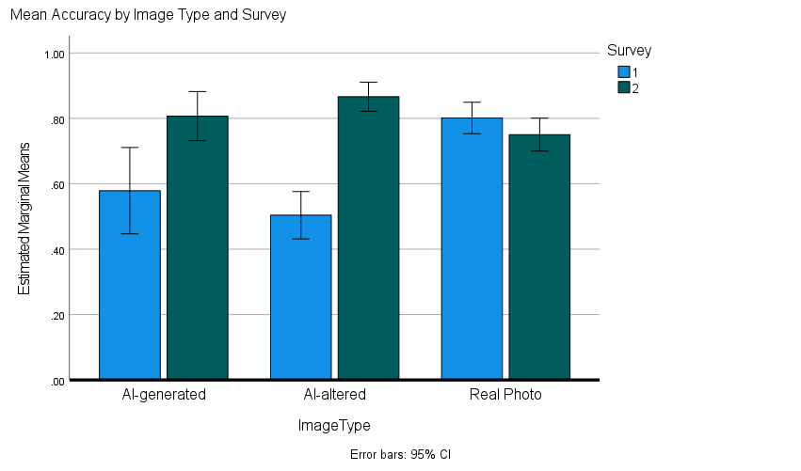
Figures:
Figure 1

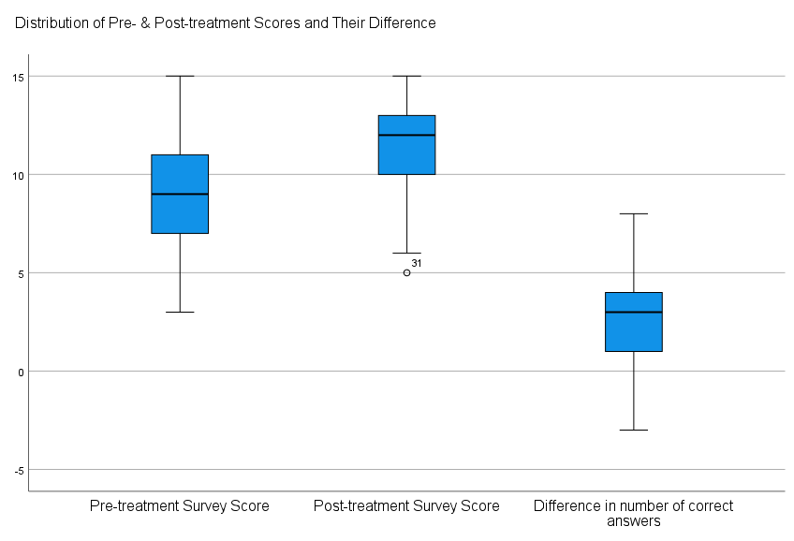
Figure 2
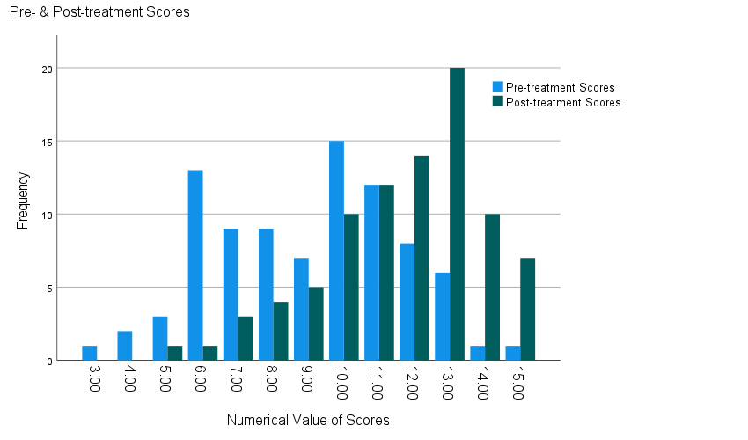
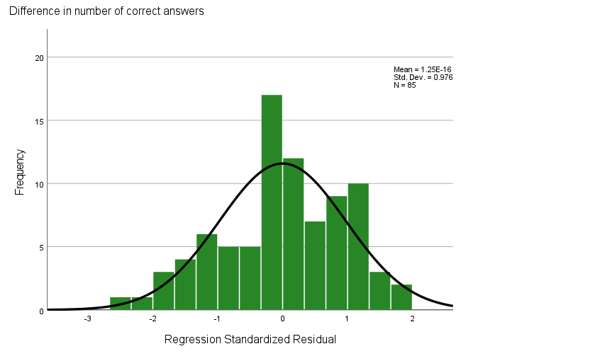
Figure 3
Figure 4
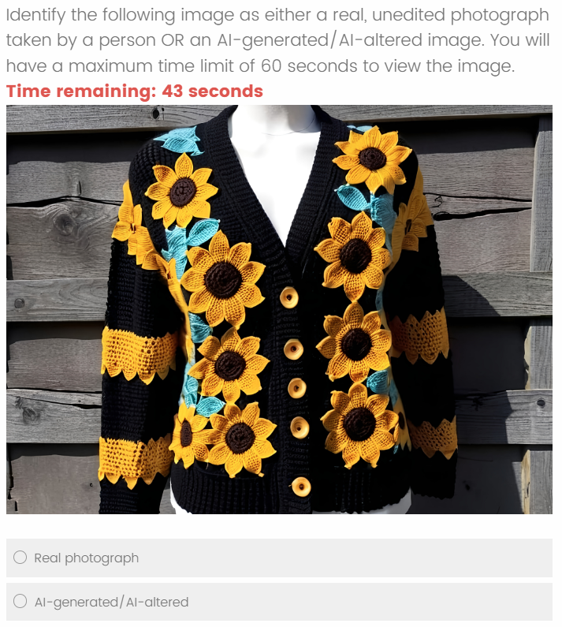
Figure 5

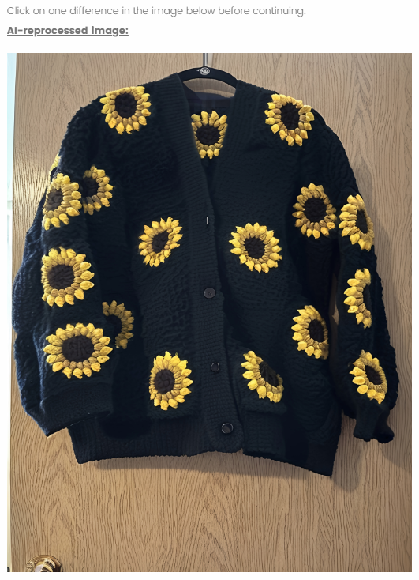
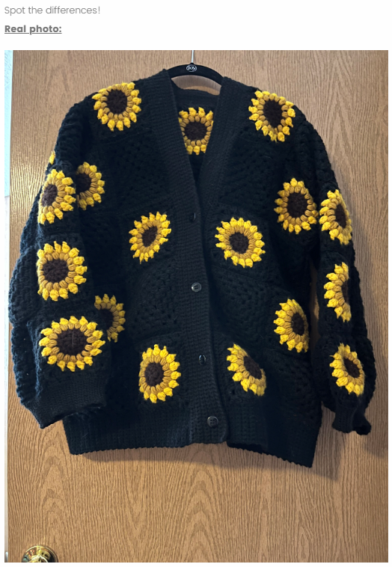
Figure 7
Figure 6
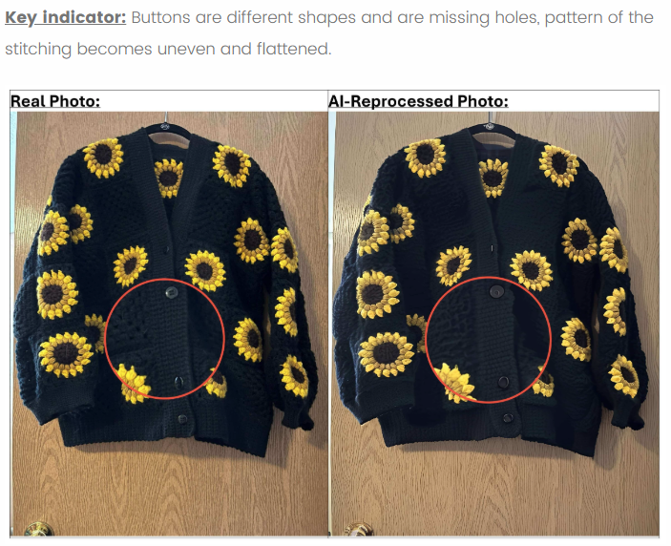
Figure 8

